SUMMERVILLE CREDIT UNION · CONSOLIDATED MEMBER GUIDE · CSUM-07 of 30
Transfer Own Account & Scheduled Transfers

Module: nFinia Digital Banking > Move Money > Transfer / Scheduled
Sources: Summerville Reports Series A (36 docs) + Series B (25 docs) | Features: nFinia Documentation Features Spreadsheet
01 PRODUCT SUMMARY

The Transfer to Own Account feature enables members to move funds instantly between their own accounts held at the credit union — for example, from checking to savings, or from savings to a loan. Transfers between own accounts are processed in real time with immediate balance updates. The four-step wizard guides members through selecting source and destination accounts, entering amount and memo, reviewing the summary, and receiving a success confirmation.
Scheduled Transfers extend the own-account transfer capability to automated recurring movements. Members can schedule weekly, bi-weekly, semi-monthly, or monthly transfers that execute automatically on the configured date. Common use cases include automatic savings contributions on payday and recurring loan payments to avoid missed deadlines.
The Scheduled Transfers view also serves as a log for completed FedNow and ACH transfers, giving members a consolidated payment history view alongside their active transfer schedules.

At a Glance

Attribute | Detail
Module | Move Money > Transfer Own Account / Scheduled Transfers
Transfer Speed | Instant (real-time for own-account transfers)
Schedule Types | One-time, Weekly, Bi-weekly, Semi-monthly, Monthly
Steps | 4 (From → To → Amount/Memo → Confirm → Success)
History View | Completed FedNow and scheduled transfer records
Related Reports | CSUM-06 (Move Money Hub), CSUM-08 (Other Members Transfer)

02 KEY USE CASES

Use Case | Who Uses It | What They Do | Business Value
Savings Top-Up | Members building savings goal | Select checking as From, savings as To, enter amount | Instant savings deposit without branch or ATM
Automate Monthly Savings | Members setting up recurring savings | Schedule weekly transfer from checking to savings after payday | Set-and-forget savings automation
Loan Payment from Savings | Members with funds in savings | Select savings as From, loan as To for immediate payment | Flexible payment source beyond primary checking account
View Scheduled Transfer Log | Members reviewing automated payments | Open Scheduled Transfers to see all active and completed schedules | Full automation history in one screen

03 STEP-BY-STEP GUIDE

Navigation: Dashboard > Move Money > 'Transfer to Own Account' OR 'Scheduled Transfers'.

Step 1 — Start from Dashboard
The member begins at the Dashboard after logging in. The Dashboard displays all account balances, upcoming payments, quick-action tiles, and the top navigation bar with links to Accounts, Move Money, and More.
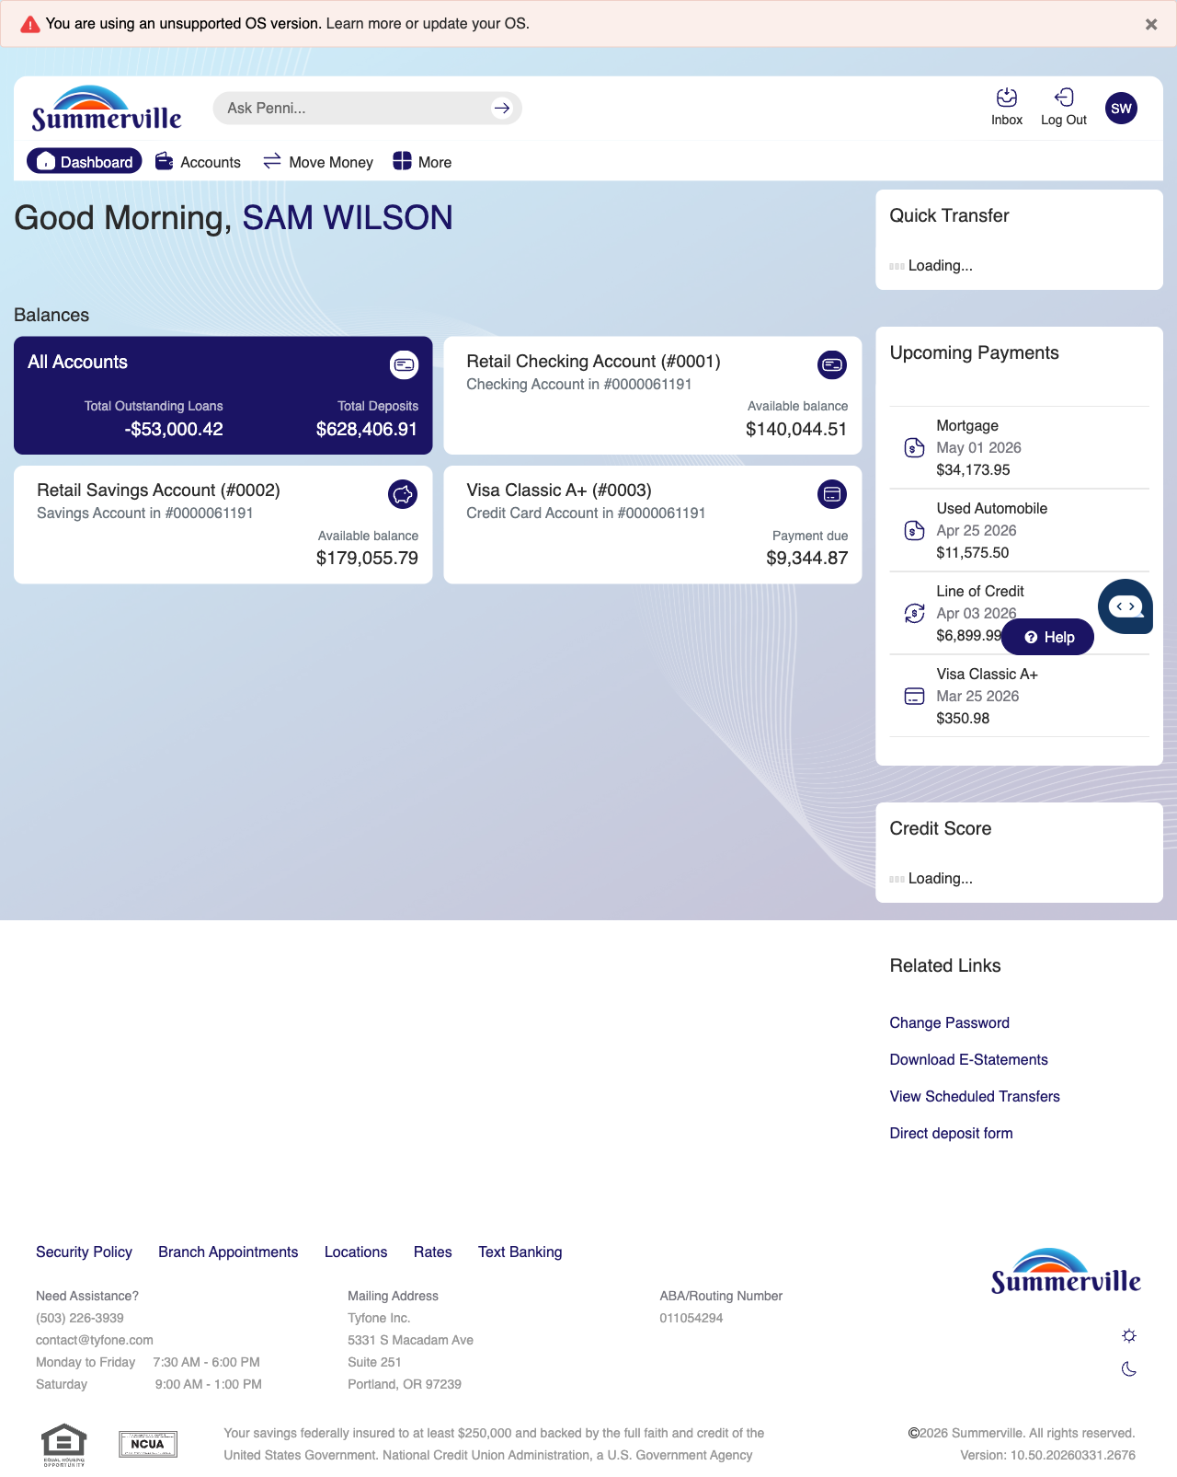
Step 1: Start from Dashboard

Step 2 — Navigate to Move Money Hub
The member clicks ‘Move Money’ in the top navigation bar. The Move Money Hub displays all payment and transfer options as tiles including Pay Bills, Quick Pay, Zelle Payment, Internal Transfers, Other Members, Same-Day Transfers, Send Instantly, Manage Recipients, Add Recipient, Transaction History, Scheduled Transfers, and P2P Transfer.
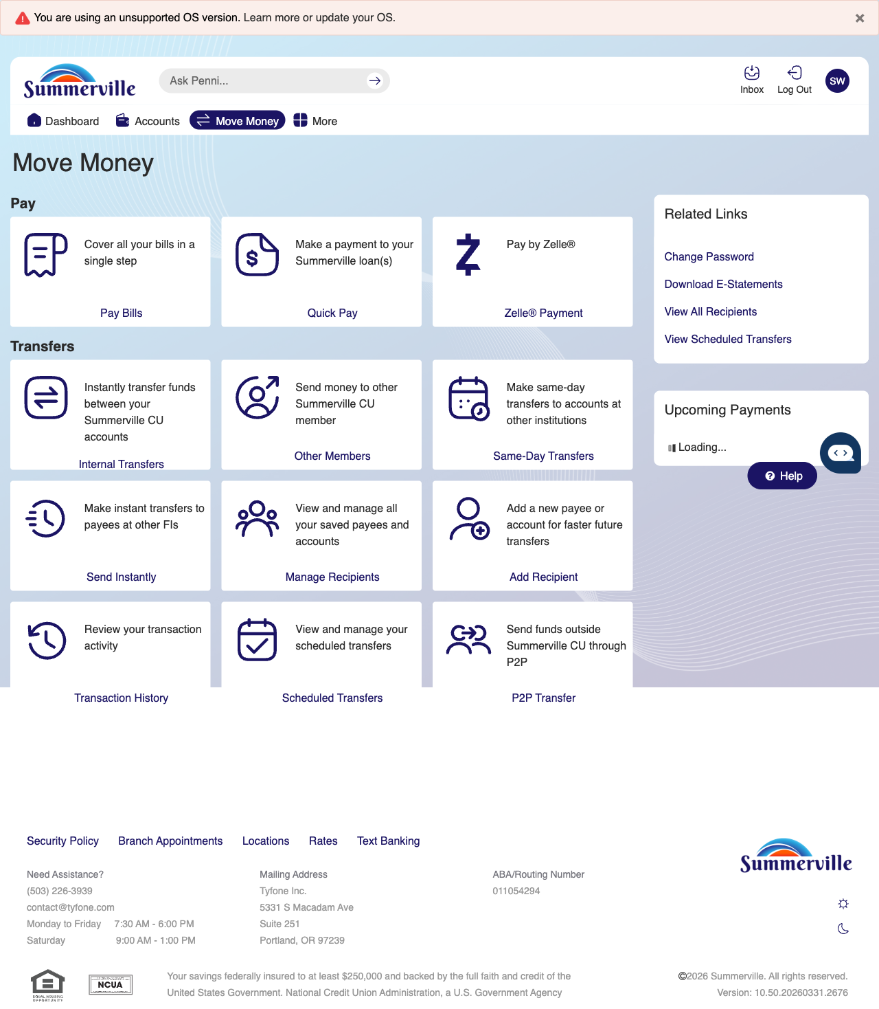
Step 2: Move Money Hub

Step 3 — Navigate from Dashboard to Own Account Transfer
Step 1 of the Own Account Transfer flow shows the account selection screen with a dropdown to choose the source account for the internal transfer.
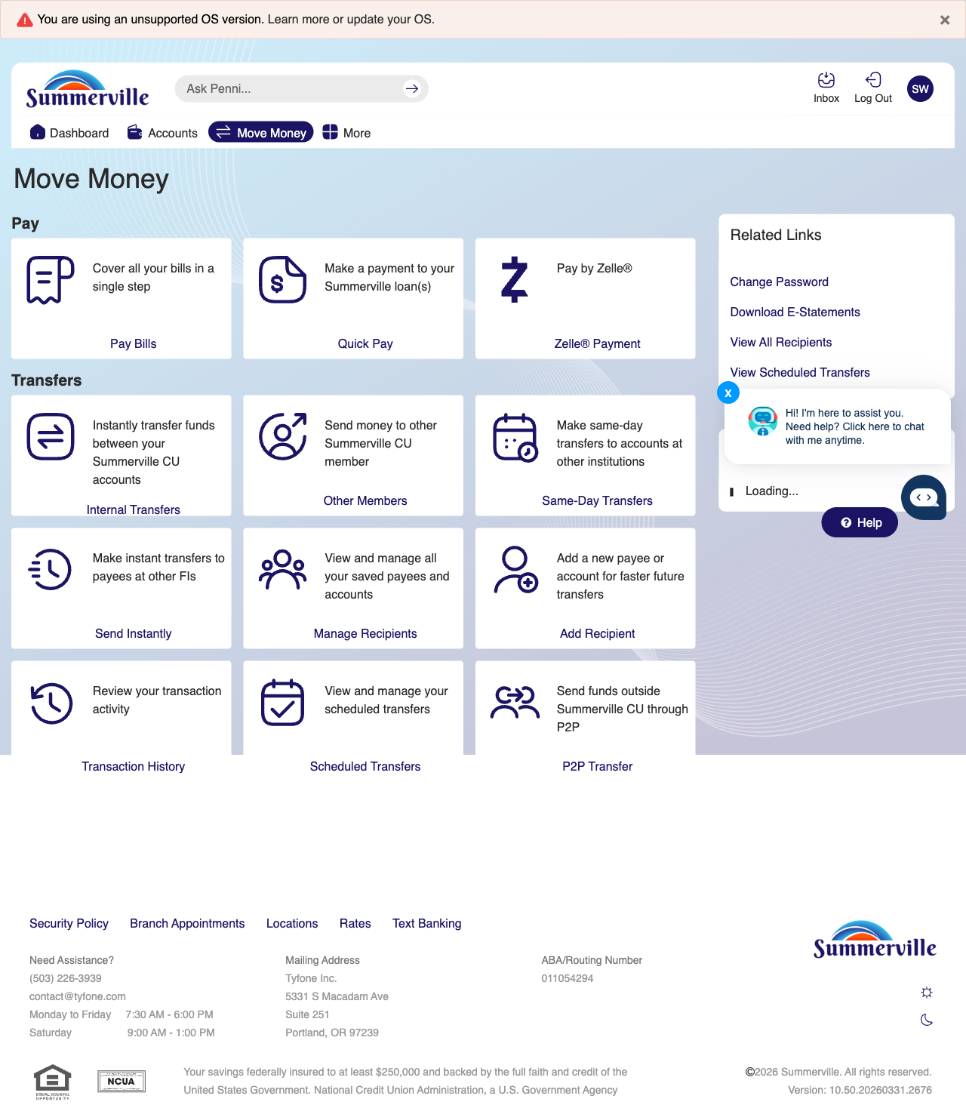
Step 3: Navigate from Dashboard to Own Account Transfer

Step 4 — Enter Amount & Memo
Step 2 displays the transfer details form with fields for entering the transfer amount, an optional transaction memo, payment date selection, and a recurring payment checkbox.
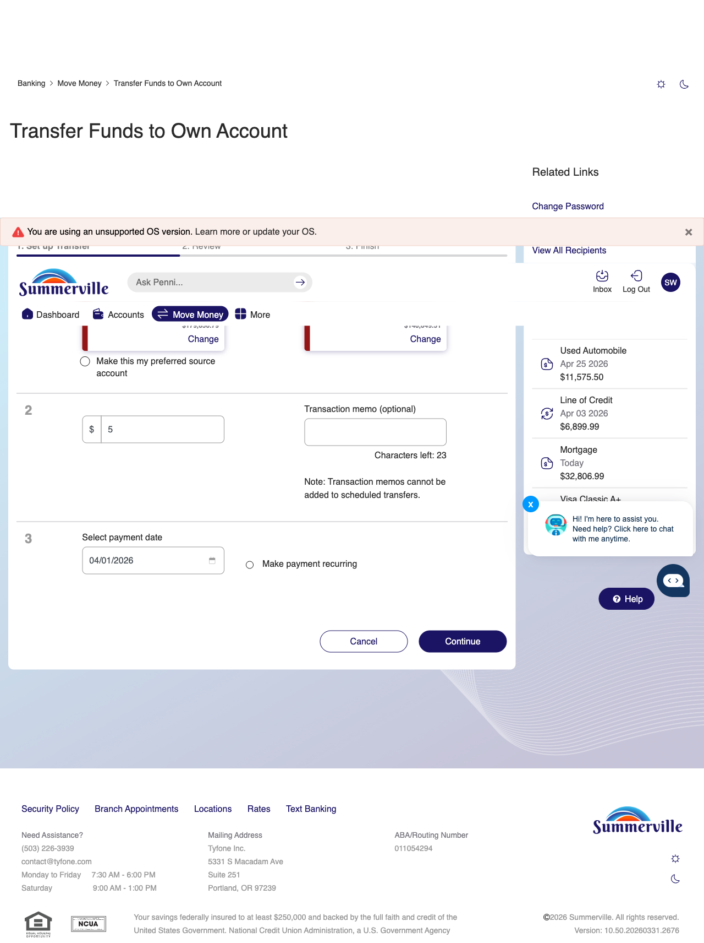
Step 4: Enter Amount & Memo

Step 5 — Review Transfer Summary
The confirmation screen shows a $5.00 transfer between Retail Savings and Retail Checking accounts, displaying the description and scheduled date for member review.
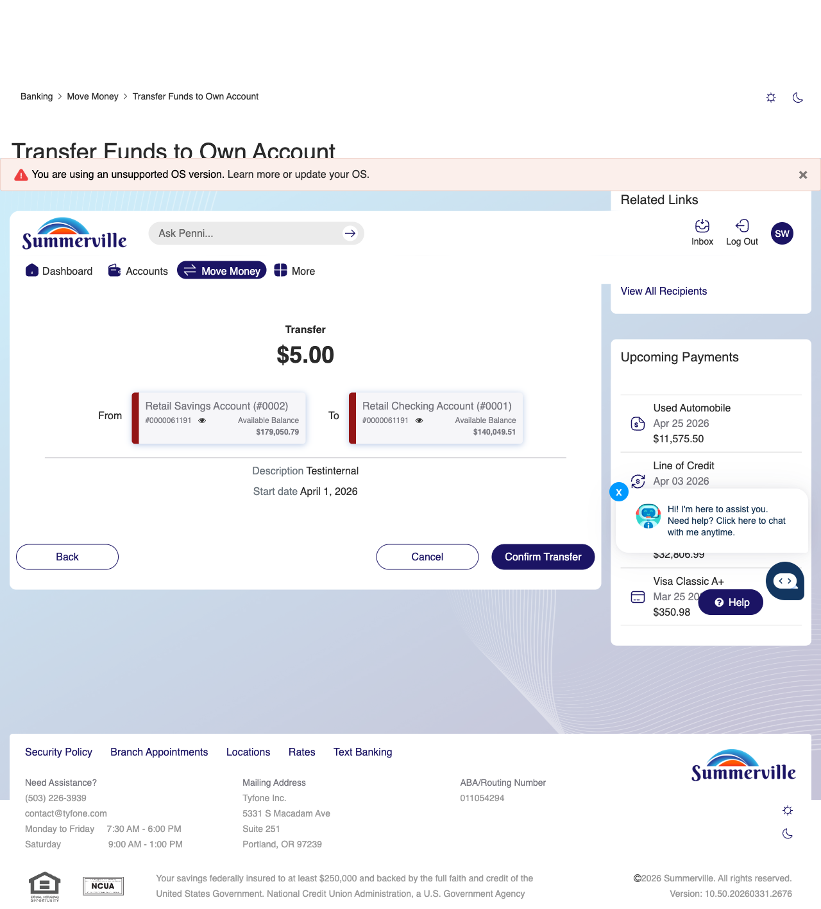
Step 5: Review Transfer Summary

Step 6 — Transfer Complete — Success Screen
A success confirmation page is displayed with a green checkmark, confirming the completed $5.00 transfer between accounts with a transfer date of Apr 01, 2026.
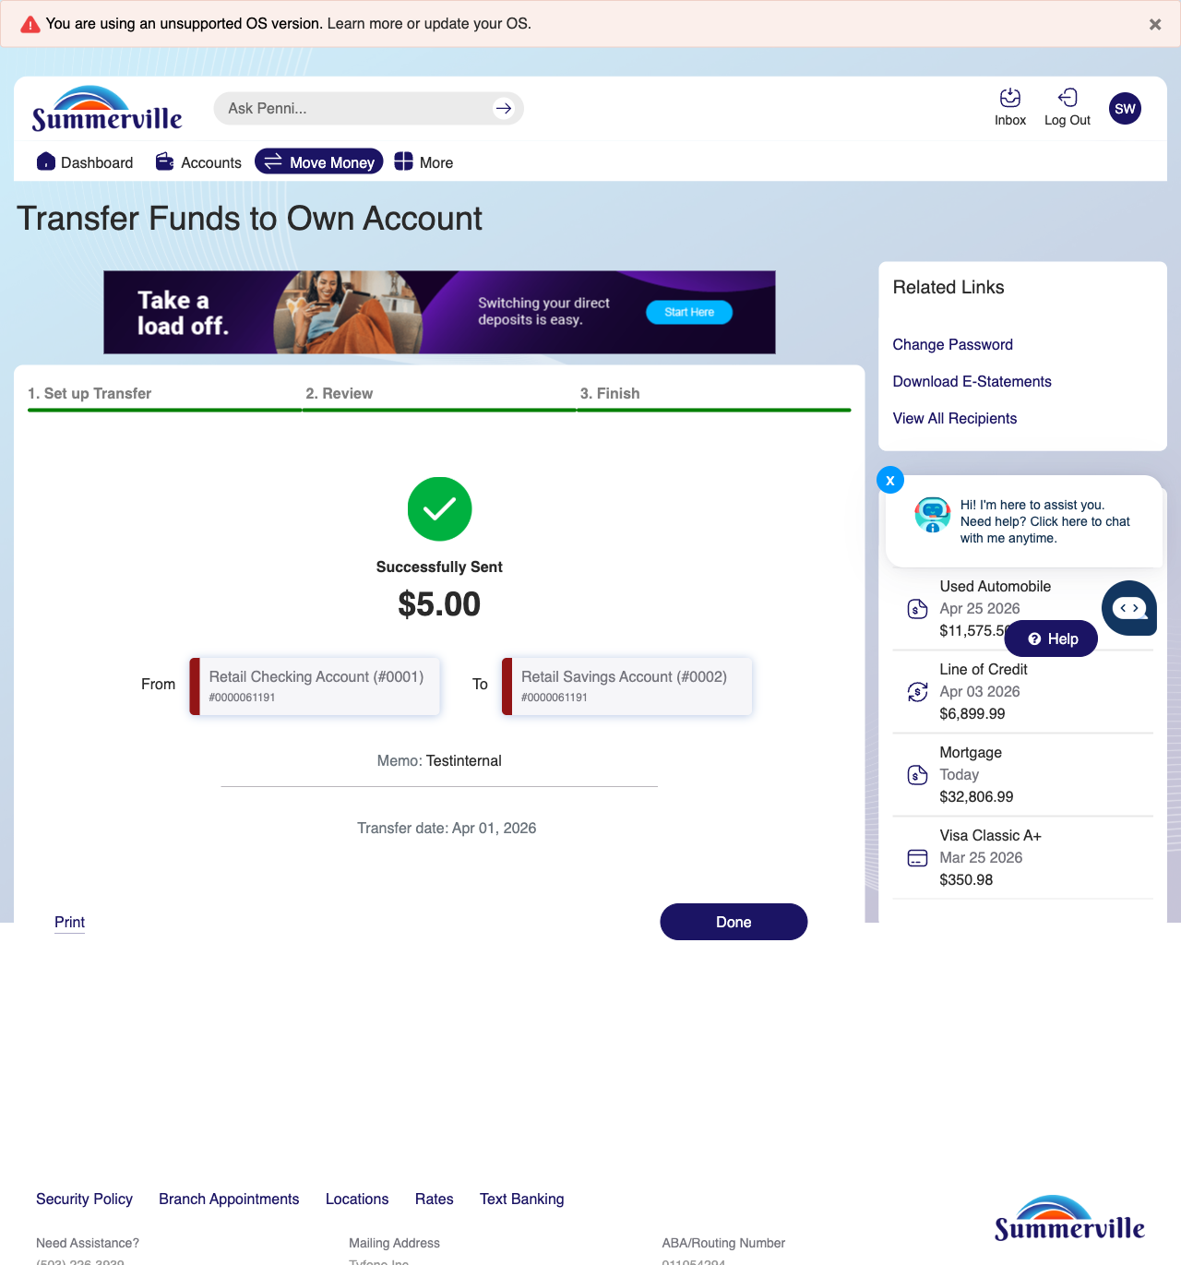
Step 6: Transfer Complete — Success Screen

Step 7 — View & Manage Scheduled Transfers
The Scheduled Transfers page is displayed with Summerville branding. A 'Schedule a new transfer' link is at the top. The schedule transfer type is set to 'Within Summerville' and the account is 'Retail Checking Account (#0001)'. An active schedule card shows a transfer from Retail Checking to SHARE (0002) for $10.00 monthly, set to continue until cancelled with the next transfer date of Mar 18, 2026. Related Links and Upcoming Payments are shown in the right sidebar.
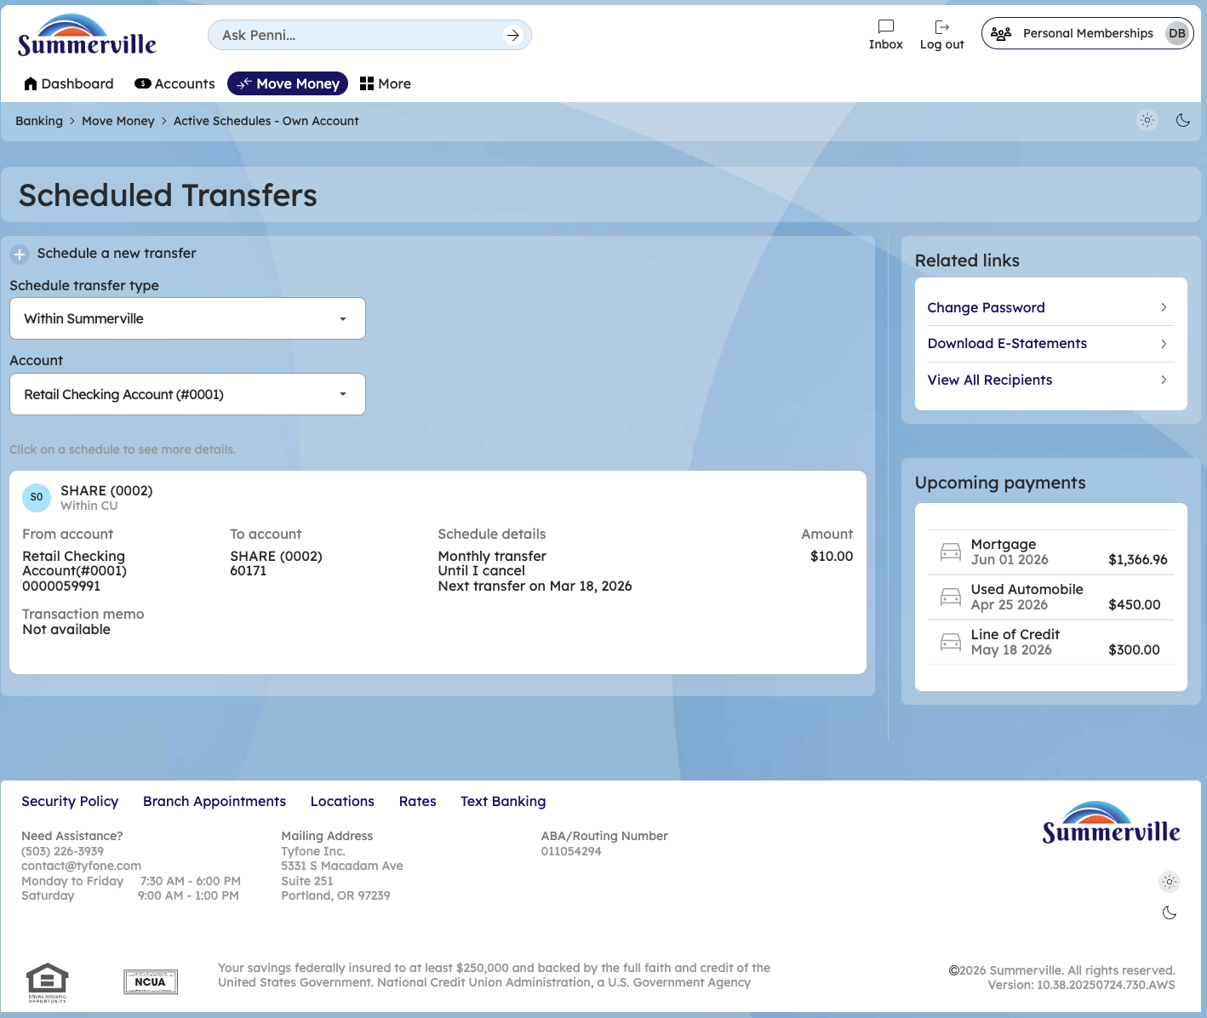
Step 7: View & Manage Scheduled Transfers

Step 8 —schedule a new transfer
To schedule a new transfer go to move money hub and click on internal transfers
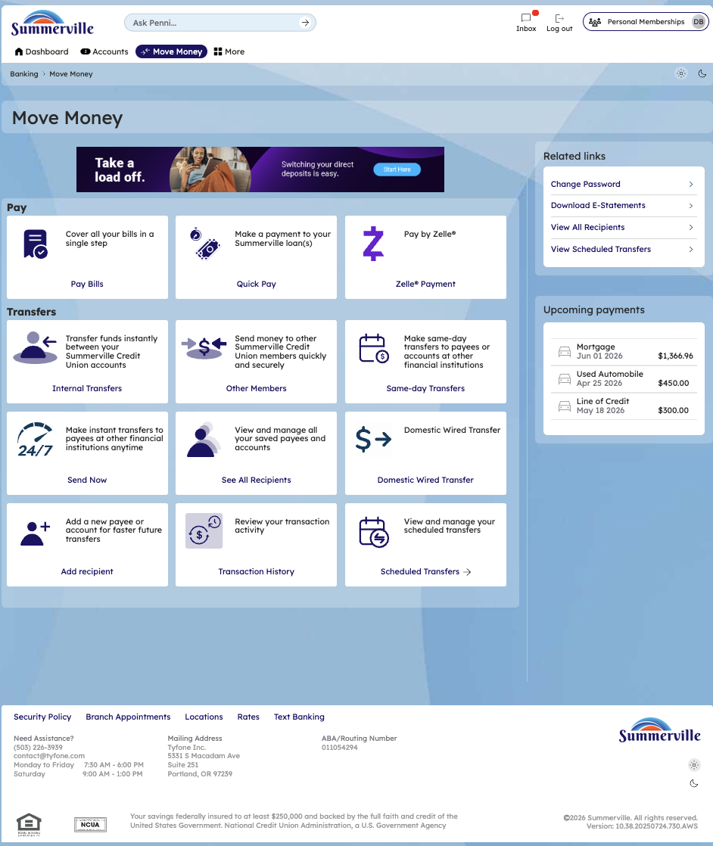

Step 9 —internal transfers
To schedule a new transfer go to move money hub and click on internal transfers and select a date you want to schedule a transfer
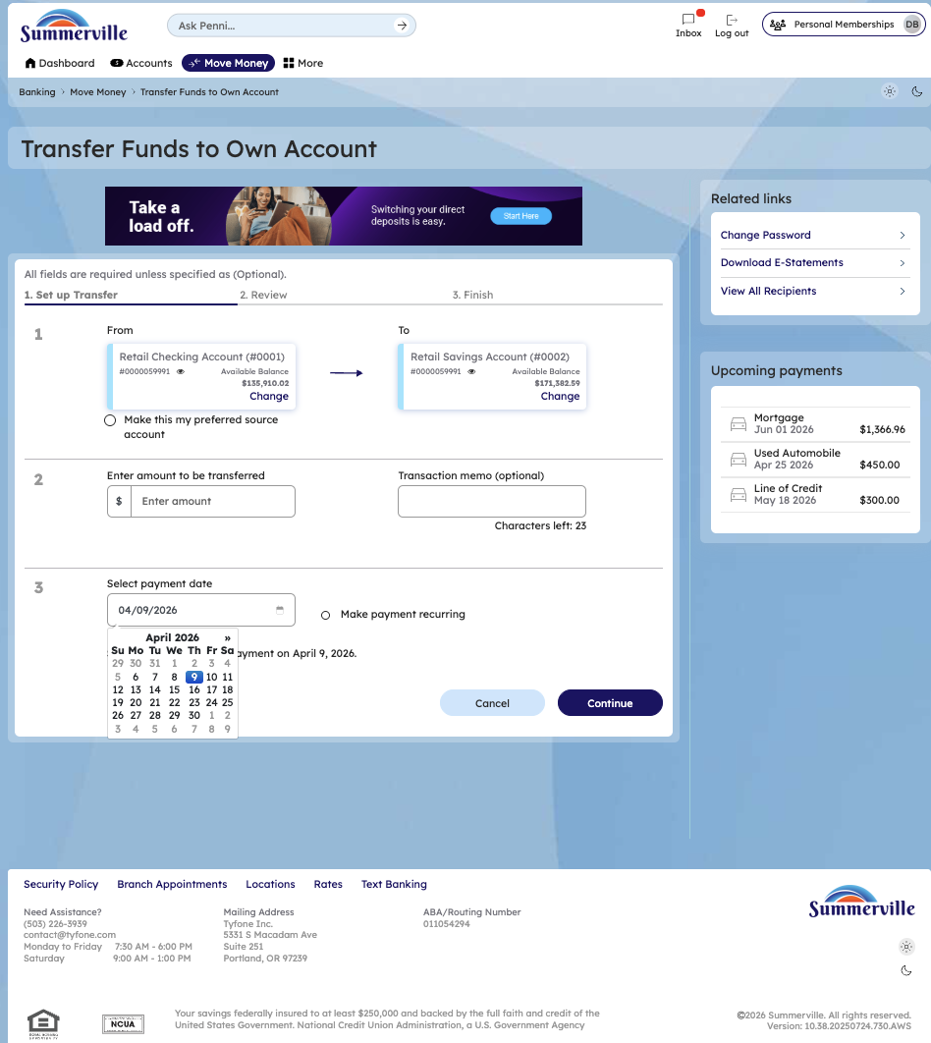
Step 10 —confirm the transfer
Confirm the transfer after entering date and amount
